President’s Message for May 2015

The next CPRA/CPIN meeting will be Thursday, May 21 at 7:00 PM at The Wharf on Derry Street in Harrisburg. Come early for food and your favorite beverage. Tim Shingara will be talking about the Dayton Hamfest and why every ham should go there at least once in a lifetime.

Slant Technology: Only from Ubiquity can you obtain Slant Technology. They act like this is an industry breakthrough. But it is brilliant. 5 GHz RF transmissions are linear polarity as are most other bands and manufacturers. They transmit vertical and horizontal polarity at 0 degrees and 90 degrees. Keith Elkins had a feedhorn cut in half to verify that Slant Technology uses -45 degrees and +45 degrees. That provides additional isolation and is very useful in a crowded city environment. The whole world is 0 degrees and 90 degrees and you are at -45 degrees and +45 degrees, BRILLIANT. This is only available in current production devices and is clearly marked. Don’t try to use the old standard with the new Slant Technology.

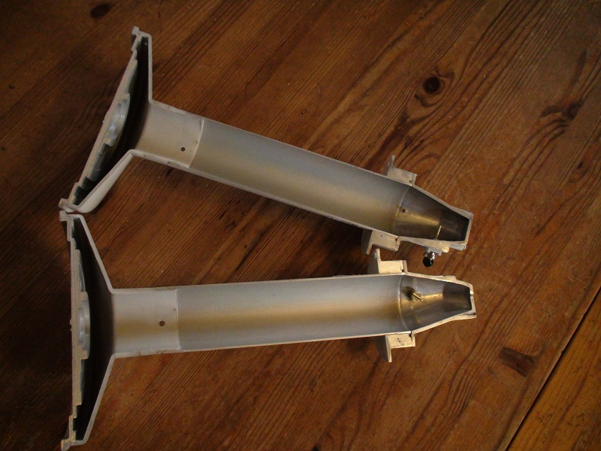

GPS SYNC
GPS Signal Quality Displays Global Positioning System (GPS) signal quality as a percentage value on a scale of 0-100%.
Latitude/Longitude Based on GPS tracking, reports the device’s current latitude and longitude. Clicking the link opens the reported latitude and longitude in a browser using Google Maps™ (http://maps.google.com).
Altitude Based on GPS tracking, reports the device’s current altitude relative to sea level.
Synchronization airFiber uses GPS to synchronize the timing of its transmissions. By default, this option is disabled. The GPS Sync has all transmitters on a tower or nearby transmitting at the same time to avoid collisions. Likewise all receivers are receiving at the same time. This allows better data throughput.

Full Duplex: The newer equipment will transmit continuously while receiving on a nearby frequency. This doubles the throughput. It can also hop based on preselected frequencies to find the best throughput. Of course simplex on a single frequency can be done. This allows transmitting 50% of the time. It can also hop based on preselected frequencies to find the best throughput. Simplex in the computer world is called Half-Duplex.

AirPrism:
Ubiquiti Networks introduces our To enhance airMAX ac performance,
patented airPrism™ technology, which is featured on the Rocket ac model,
R5AC-PTP. http://www.streakwave.com/Itemdesc.asp?ic=R5AC%2DPTP%2DUS&o1=0
Improves SNR
High data rates require a high Signal‑to‑Noise Ratio (SNR), which is challenging to achieve, especially in noisy, high‑density areas. Integrated into Ubiquiti’s custom
silicon, airPrism technology creates a high SNR by isolating signals within the operating channel and rejecting interference using specialized circuitry, the High‑Selectivity Receiver
Removes Interference
Depending on the product model and operating mode, available channel
widths may include 10, 20, 30, 40, 50, 60, and/or 80 MHz.
Theoretically APs operate on different channels; however, because of the wider channel bandwidths, there can be overlap in spectrum usage. airPrism technology removes up to an additional 30+ dB of adjacent channel interference through the active
filtering design, so an airMAX ac AP with airPrism technology can provide
significantly greater performance than a typical AP.
Facilitates AP Co-Location
Co-location is vital in many scenarios. For example, a WISP may have limited tower space, so it must co‑locate all APs within that allotted footprint. Shielding and other means can lessen interference but may be impractical.
By deploying airMAX ac APs with airPrism technology, you can
co‑locate APs and enhance the overall performance of your wireless network.
Number of APs Channel Width
JAVA DOESN’T WORK: Just when everything is working fine, Google throws a monkey wrench into the mix. Oracle purchased Java from Sun. Google had a falling out with Oracle. The Chrome browser is owned by Google. Chrome won’t support Java without jumping through some hoops. They say by the end of the year Java won’t work at all with Chrome. Almost all Ubiquity transmitters have a built-in Spectrum Analyzer that uses Java. That is why we have a big problem. Internet Explorer will run Java but we must provide an exception for the added security of the latest Java release. Go to your Control Panel and select Java. On the Java Control Panel select the security tab.
- Enable Java content in the browser (check the box)
- Security should be high not very high
- Edit exception site list
- Every web site or device must have their address added here
- Example: HTTP://172.16.5.224:80
- Then left click OK
Wait. There is more. Go to the Tool menu on Internet Explorer. Left click on Compatibility View Settings. Add the web site or device to the list. Example: 172.16.5.224
Now your browser will allow you to view the Spectrum Analyzer. Thank You Oracle.

FREE STUFF
- Rack 65 “ tall, ventilation openings on all sides, with rear door One only
- 3COM 24 port rack mounted switch with ears and power cable more than five
Contact Gary at 574-0425 for pickup times.
- 94 amp hour deep cycle batteries will be available this summer

Blue Mountain Projects:
- Removal of Metal Building: plan C is needed
- Electrical supply to Building Three
- Relocation of Sector Antenna for better coverage.
Upgrade to slant sector, gigabit Ethernet & switch, higher throughput Rocket ?
Upgrade clients ?
- Install 147.375 antenna on building as a temporary first step

Twisted Pair: Political issues may be solved. This software allows remote control of multiple repeater functions and cross-linking. For instance the Lancaster County amateur repeater at Truce can be remotely controlled at the Lancaster County EOC.
http://urgentcomm.com/motorola-solutions/motorola-solutions-buys-twisted-pair

UHF Repeater Interconnect: At least four UHF repeaters have an operational Cisco router in place. Final adjustments are needed before going live.

CPRA/CPIN Learning Experiences: They have returned. A schedule is forthcoming so that hams can participate with hands on projects designed as a learning experience. More discussion this Thursday at the meeting at The Wharf.

ARRL Field Day is June 27 & 28: We are fortunate to have so many field day opportunities in this area. http://www.arrl.org/field-day
HRAC and SMRA have field day locations that have been fine-tuned over the years.
N3TWT
South Mountain Radio Amateurs
180 Army Heritage Drive
Carlisle, 17013, PA
GOTA: YES
Talk-in: 145.43 @ 67.0
Contact: Donald Evans President
717-418-1700
uxltel@comcast.net
WWW.N3TWT.org
http://www.w3uu.org/

Firecracker Hamfest:
http://www.w3uu.org/wp-content/uploads/2013/09/HAMFEST-FLYER-July-2015.pdf
Saturday JULY 4th 2015

