CPRA/CPIN APRIL 2024 NEWSLETTER

The next CPRA/CPIN Meeting is Thursday, April 18, 2024.
Join us at a new location !
Meeting reservations have been confirmed for 6:00 PM.
Hibachi Grill
5080 Jonestown Road, Harrisburg, Pa 17112.

Welcome to our new Meeting location:

Last month we held our first meeting at the Hibachi Grill in Harrisburg. The room was partially occupied by regular diners with children and was a bit noisy until they left. Hopefully we won't have an issue such as this again as we are expecting to have a presentation from Jason on the POTA expedition to the Dry Tortugas. They racked up nearly 4000 contacts in 3 days!

The price for the buffet is reasonable and the food selection and quality is good. The Ham Luncheon group has used this location for years.

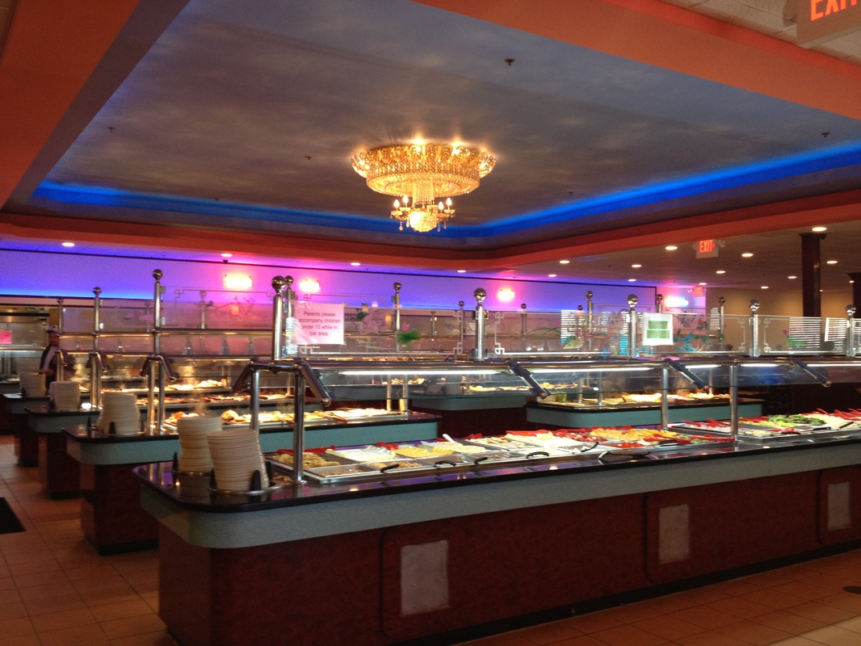

APRIL is also election of club officers. The current slate has been renominated, but if you would like to change that list, please come to the meeting and place your name into nomination. See the bottom of the last page of this newsletter for the list.

Camera status:

There have been many network outages this past month and the public access has needed to be reset a few times. It is currently down. Jason has been working on the second server and is currently testing a third party vendor's software with our Ubiquity cameras.

Project Updates:

Waggoner's Gap SOLAR Project:

A new breaker is rated at 50 amps was placed in service and max charging current limits were increased to 46 amps. The past 3 days (long weekend) saw max charging voltage reached by 10 AM each morning,

We still need to clear all of the cables that are stored there from the floor so that the floor can be replaced.

A second person is needed to assist with attaching the battery rack to the exterior wall. In February, a second set of deep cycle AGM batteries were donated and installed to effectively double our amp-hour capacity from 215 to 440.

215 amps X 24 volts = 5.16 KWH (fully charged) X 50% (AGM battery usable capacity) = 2.58 KWH
440 amps X 24 volts = 10.64 KWH (fully charged) X 50% (AGM battery usable capacity) = 5.32 KWH
No SUN Usage 18 Hours X 100 Watts =1.8 KWH

Red Lion - Reeser's project:

The first redundant link in our microwave system is well underway. The transmitters and dish have been mounted on the north railing with proper grounding installed. The Reeser's link dish and radio were delivered on schedule in March.

There are still issues at the Red Lion site. The link to SPARC went down at 5:58 PM on March 2. It was determined that the M5 transmitter at Red Lion lost its memory and reset itself to factory defaults. A new transmitter has been program but not yet mounted. The dish is outside the safety railing and winds have been typical March gusts.

We are also having network issues with path fading on the link from Mt. Holly to Blue Mountain, particularly on windy days. Do we have a dish not locked down, or is it the super old rusted tower at Blue. KB3YRC called for a work party at Blue to find out, but repairs could not be made. One major issue is a TV yagi placed on the opposite face of the tower a few feet below our dish. It is believed that this is for the WGAL translator. It was decided not to disturb it. A new plan is being developed.

Other Pending Projects:

CPRA Microwave: Construction on the WITF tower is complete with full access now available to the site at Blue Mountain. Work should commence shortly on the standby tower work and dish orientation to Nally's with a tower crew procured by Kevin. Ubiquiti Power Beam 5AC units with a 27 dBi feed horn are set aside for the links from Nallys to Manada Hill, and Manada Hill onto Northern Lebanon.

In the meanwhile, it was decided to move the two big links at Blue to the standby tower and have another climber do the work. The 3 foot dishes towards Cornwall and Mount Holly plus a zoom camera will be mounted on the tower. A climber has been found to do the work. We do need to determine what mounting arrangements will be needed and the height location before he is scheduled. New CAT-6 cables will be run under the ice bridge.

Mass Evacuation Drill (NMCE):

Discussion has been made on participating in a Mass Evacuation drill at Shippensburg on May 22.
We will use this opportunity to demonstrate our ability to provide needed services. We can connect the evacuation center to our network and offer the following services to county and local Emergency Operations Centers, 9-1-1 call centers and other first responders that may be of value during the NMCE drill:

- PBX telephone service. CPIN participants can use the system to dial a three-digit extension to put them in direct voice or FAX contact with other emergency service responders. Although our group is comprised of amateur radio operators, you do not need a ham radio license to use this system. First responders at the evacuation center.

- Public landline phone. We also have the ability to offer a single landline telephone to the evacuees to contact their loved ones.

- Connections to the public Internet through gateways in widely separated geographical locations. If the Internet fails in a given area, CPIN will still be connected to the web at other physically separate locations. This feature is operational and we are in the process of adding additional gateways for greater reliability going forward.

- Video services. Cameras can be set up at the evacuation center to allow emergency services personnel at the Cumberland County Emergency Operations Center to view conditions in and/or outside the evacuation center in real time.

- WiFi services. Through our Internet gateways we can offer WiFi service within the evacuation center to both first responders and to evacuees. This would allow evacuees to use their mobile devices to exchange text and email messages with loved ones should the cell phone network fail. It would also allow evacuees to place telephone calls on their personal mobile devices by using their WiFi calling feature.

Other Reminders:

CPRA DMR Local 2 Net every Sunday at 9 PM. Tune-in every Sunday night. Get on DMR radio as often as possible to increase the number of contacts.

Ham Luncheon on the last Thursday of each month at the Hibachi Grill on RTE 22 by Hobby Lobby and Dicks Sporting Goods. 5080 Jonestown Road, Harrisburg, Pa 17112. The next luncheon is on March 28th.

The club's membership form has been placed on-line at www.w3nd.org. It may be found at the bottom of the page. Be sure to click on the Submit button after you fill out the form. The payment plug-in is now active. You may fill out the membership to update your information, you may renew your membership or even make a donation.

Are you interested in Packet and digital modes? 145.01 and 29.13 are being used locally. A proposal is being entertained for a possible site at Reeser's Summit. Talk to Chip, K3FUD, and Jason, N8WXZ, if you are interested.

Hamfest season will be starting soon. Saturday, April 27, will be the York Area Springfest, which will be held at Eliker's Grove again this year. The site is west of Thomasville on US 30, turn south onto Roth's Church Road. Gates open for buyers at 8 AM.

Looking for solutions? Need connectors, antennas, antenna mounts, mag mounts, cable assemblies, or even Motorola radios ? We recommend a local source:
Capital Area Communications
4120 Swatara Drive, Harrisburg PA, 17113
just off Eisenhower Blvd. between Chambers Hill Rd. and Lingle Rd.

Tel: 717-561-0800 https://www.cacradio.com/ Mail: info@cacradio.com

Contact Dan Rake for all your needs.

CPRA OFFICERS FOR 2023
President
Gary Blacksmith, WA3CPO
Vice President
Kevin Magloughlin, KA0JQO

Secretary
Chip Kroh, N3FUD
Treasurer
Jason Bachman, N8WXZ
Trustee
Kevin Magloughlin, KA0JQO
Member at Large
Nick Rylatt, AA3T
John Zilavy, KC5DRI
Richard Lenker, KB3YRC
Dan Rapak, WA3ATV

Dues are $25 per year for individual membership and $35 per year for family membership.
Life membership is $500. Send your check now to BOX 1444.

Do not send cash. Make your checks payable to:

CENTRAL PENNSYLVANIA REPEATER ASSOCIATION, INC

P O BOX 1444, Mechanicsburg, Pa 17055

RENEWAL OR APPLICATION FOR MEMBERSHIP IN CPRA
□ 2023 □ 2024 □ 2025 □ 2026
□ New member □ Renewal □ Family □ Life
□ Donation ______________ □ Other ______________________
Total amount enclosed $ ____________
Name:___________________________________ Call(s)_________________
Address: ______________________________ City: ______________________
State: ________ Zip code __________ License class: ____________________
Email address for newsletters: ________________________________________
Phone: _______________________ □ Listed □ Unlisted
Are you an ARRL member? □ Yes □ No
Are you a member of WITF □ Yes □ No
EMERGENCY RACES VOLUNTEER INFORMATION
This information will only be used in the event of an emergency. This information will only be given to the emergency RACES coordinator and will not be distributed for general information in any form!

Work number including extension: _______________________________

Cell Phone: __________________________________________________

Email address: ________________________________________________
Note: All of this may be filled out and payments submitted on-line at W3ND.org

